SRR5368803 Result Section
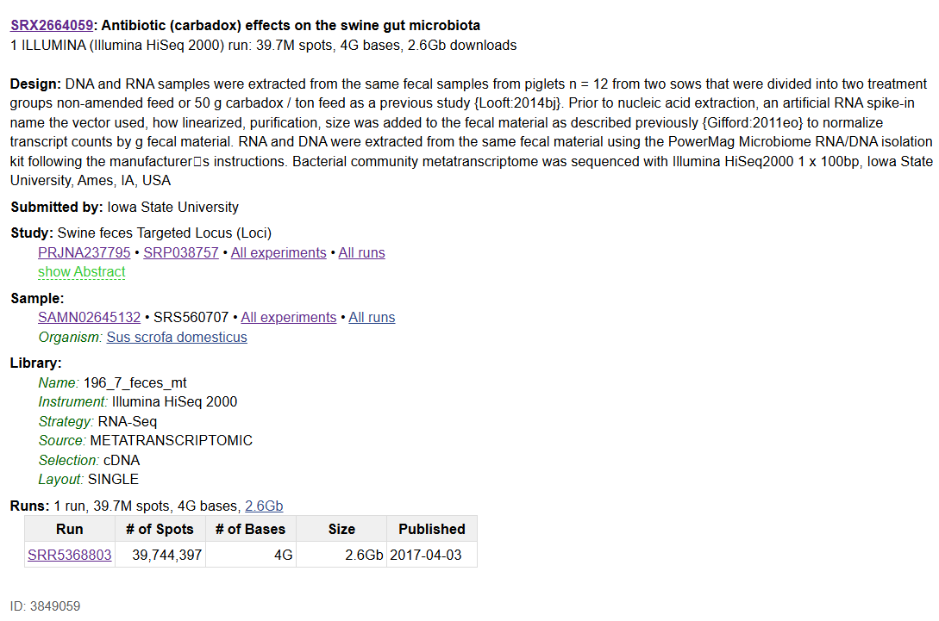
Sample attributes
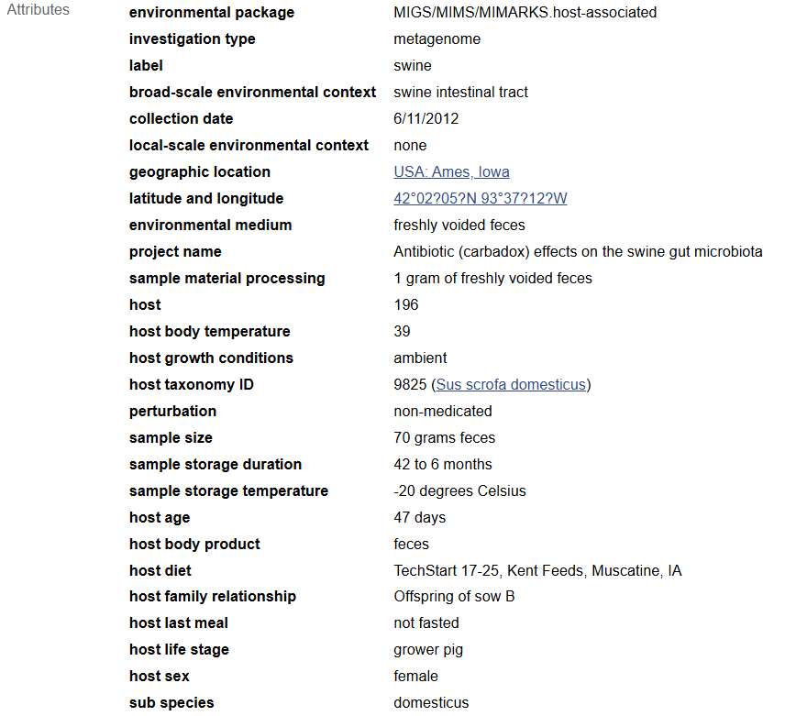

Details for SRR5368803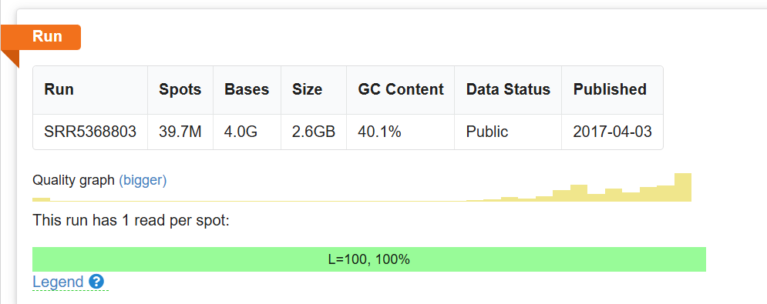
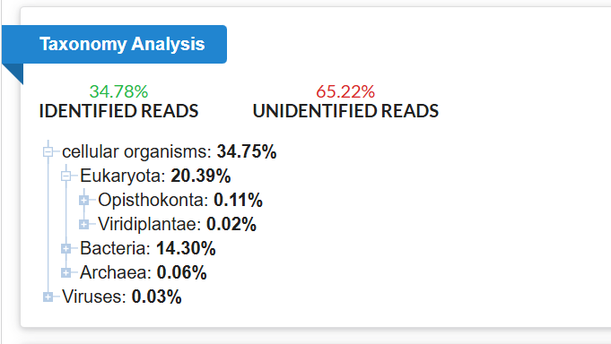
Although the SRA taxonomy summary for SRR5368803 reports only 0.03% ‘viral’ reads, this value reflects rapid k-mer–based classification of raw reads and is not a reliable indicator of RNA virus abundance. Most RNA viruses, particularly narnaviruses and mitoviruses, lack close reference genomes and therefore remain unclassified at the read level. Indeed, 65.22% of reads in this dataset were labeled ‘unidentified’ (page 2), and it is within this fraction that the viral contigs were assembled. The successful recovery of the RdRp sequence by Serratus highlights how targeted motif-based searches can detect highly divergent viruses that are invisible to standard taxonomic classifiers.

